|  |  |
| --- | --- |
| Sensor | Port # |
| Wind speed & direction | 1 from left side |
| Rainfall | 2 |
| Soil Temperature/Moisture Sensor - SHT10 | 3 |
| Spark Fun Soil Moisture Sensor | 4 |
| DHT31-D Temperature & Humidity sensor | 5 |
| Solar Radiation | 6 |
| PHYTOS 31 leaf wetness | 7 |

1- DHT31-D Temperature & Humidity sensor

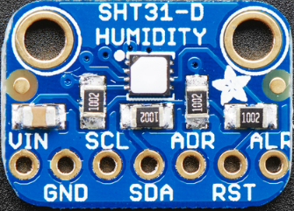

|  |  |
| --- | --- |
| Sensor pin | Arduino pin |
| VIN | 5V |
| GND | GND |
| SDA | SCL21 |
| ADT | SDA20 |

2- SparkFun Soil Moisture Sensor

|  |  |
| --- | --- |
| Sensor pin | Arduino pin |
| SIG | A1 |
| GND | GND |
| VCC | D6 |

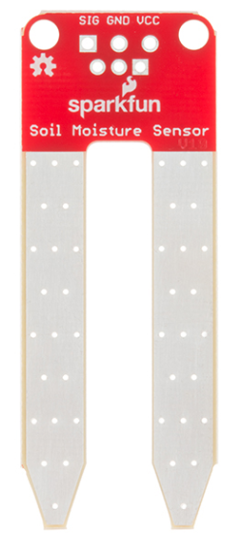

3- Soil Temperature/Moisture Sensor - SHT10

|  |  |
| --- | --- |
| Soil Temperature/Moisture Sensor - SHT10 has four wires as shown below based on their color | |
| Sensor pin | Arduino pin |
| Green | GND |
| Read | 5V |
| Blue (dataPin) | D10 |
| Yellow (clockPin) | D11 |

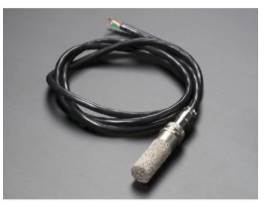

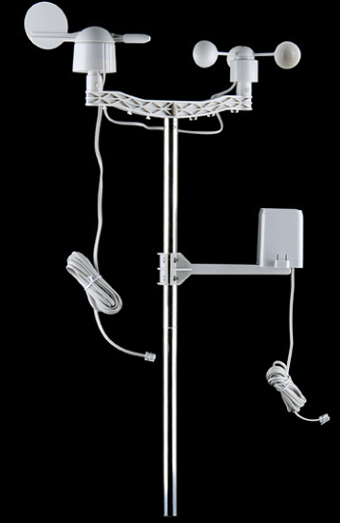4- SparkFun Weather Meters

|  |  |
| --- | --- |
| Wind Speed and Wind Direction meter has four Wires as shown below based on their color | |
| Sensor pin | Arduino pin |
| Green | GND |
| Black | 5vA2 |
| Read | GND |
| Yellow | D3 |

|  |  |
| --- | --- |
| Rain gauge has two wires as shown below based on their color | |
| Sensor pin | Arduino pin |
| Green | D9 |
| Red | GND |

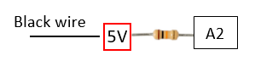

10k

5- Davis Instruments 6450 Solar Radiation Sensor

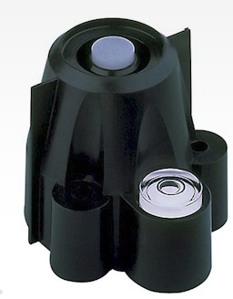

|  |  |
| --- | --- |
| Solar Radiation Sensor has four Wires as shown below based on their color | |
| Sensor pin | Arduino pin |
| Green | A0 |
| Black | GND |
| Read | GND |
| Yellow | 3.3 Volts |

|  |  |  |
| --- | --- | --- |
| PHYTOS 31 leaf wetness sensor has three Wires as shown below based on their color | | |
| Sensor pin | Arduino pin | |
|  | | GND |
| A3 |
| D5 |

6- PHYTOS 31 leaf wetness sensor

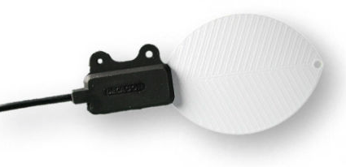

**Adafruit ATWINC1500 WiFi Breakout**

The **Adafruit ATWINC1500 WiFi Breakout** uses SPI to communicate, so with about 6 wires, you can get your wired up and ready to go. Right now the Atmel-supplied library works great with Arduino Zero, and seems to work OK on Uno but may not work on other Arduinos. You can clock it as fast as 12MHz for speedy, reliable packet streaming. And scanning/connecting to networks is very fast, a few seconds.

This module works with 802.11b, g, or n networks & supports WEP, WPA and WPA2 encryption. You can use it in Soft AP mode to create an ad-hoc network. For secure client connections, there is TLS 1.2 support in firmware 19.4.4!

Since this is our new favoritest SPI-protocol WiFi module we've decided to make a little breakout for it. The breakout comes with level shifting on all the input pins so you can use it with 3V or 5V logic. A 3.3V voltage regulator that can handle the 300mA spikes lets you power from 3-5.5VDC. There's also 3 LEDs that you can control over the SPI interface (part of the library code) or you can have controlled by the Arduino library. They'll light up when connected to an SSID, or transmitting data

|  |  |
| --- | --- |
| Adafruit ATWINC1500 WiFi Breakout | |
| Sensor pin | Arduino pin |
| Vin | 5V |
| GND | GND |
| SCK | 52 |
| MISO | 50 |
| MOSI | 51 |
| CS | 5 |
| EN | 2 |
| IRQ | 7 |
| RST | 4 |
| WAKE | Non |
| CFG | Non |
| RAD | Non |
| TXD | non |

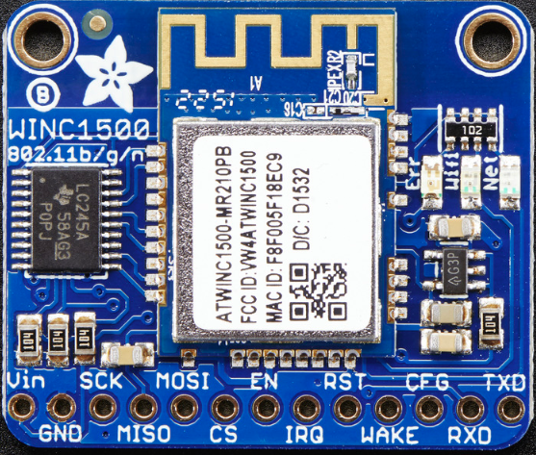

**DS3231 real time clock**

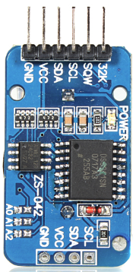

|  |  |
| --- | --- |
| DS3231 real time clock | |
| Sensor pin | Arduino pin |
| VCC | 5V |
| GND | GND |
| SCL | SCL |
| SDA | SDA |

**Description:**  
  
DS3231 is a low-cost, extremely accurate I2C real-time clock (RTC), with an integrated temperature-compensated crystal oscillator (TCXO) and crystal. The device incorporates a battery input, disconnect the main power supply and maintains accurate timekeeping. Integrated oscillator improve long-term accuracy of the device and reduces the number of components of the production line. The DS3231 is available in commercial and industrial temperature ranges, using a 16-pin 300mil SO package.  
RTC maintains seconds, minutes, hours, day, date, month, and year information. Less than 31 days of the month, the end date will be automatically adjusted, including corrections for leap year. The clock operates in either the 24 hours or band / AM / PM indication of the 12-hour format. Provides two configurable alarm clock and a calendar can be set to a square wave output. Address and data are transferred serially through an I2C bidirectional bus.  
  
A precision temperature-compensated voltage reference and comparator circuit monitors the status of VCC to detect power failures, provide a reset output, and if necessary, automatically switch to the backup power supply. In addition, / RST pin is monitored as generating μP reset manually.  
  
**Feature:**  
  
Save time and high precision addition, DS3231 also has some other features that extend the system host of additional features and a range of options. The device integrates a very precise digital temperature sensor, through the I2C * interface to access it (as the same time). This temperature sensor accuracy is ± 3 ° C. On-chip power supply control circuit can automatically detect and manage the main and standby power (i.e., low-voltage battery) to switch between the power supply. If the main power failure, the device can continue to provide accurate timing and temperature, performance is not affected. When the main power re-power or voltage value returns to within the allowable range, the on-chip reset function can be used to restart the system microprocessor.  
  
**Specification:**  
  
Battery: CR2032 (update on October 25th)  
Size: 38mm (length) x 22mm (Width) x 14mm (height)  
Weight: 8g  
Operating voltage: 3.3 - 5.5V  
Clock chip: High-precision clock chip DS3231  
Clock Accuracy: 0-40 °C range, the accuracy 2ppm, the error was about 1 minute  
Calendar alarm clock with two  
Programmable square-wave output  
Real time clock generator seconds, minutes, hours, day, date, month and year timing and provide valid until the year 2100 leap year compensation  
Chip temperature sensor comes with an accuracy of ± 3 °C  
Memory chips: AT24C32 (storage capacity 32K)  
IIC bus interface, the maximum transmission speed of 400KHz (working voltage of 5V)  
Can be cascaded with other IIC device, 24C32 addresses can be shorted A0/A1/A2 modify default address is 0x57  
Packing: single anti-static packaging  
  
Wiring instructions (with Arduino uno r3 for example):  
SCL → SCL /A5  
SDA → SDA /A4  
VCC → 5V  
GND → GND

**Adafruit SD card breakout**

|  |  |
| --- | --- |
| Adafruit SD card breakout | |
| Sensor pin | Arduino pin |
| 5V | 5V |
| GND | GND |
| CLK | 52 |
| DO | 50 |
| DI | 51 |
| CS | 53 |

